**WEKA EXPLORER MODULE ANALYSIS:**

KNN Training Model:

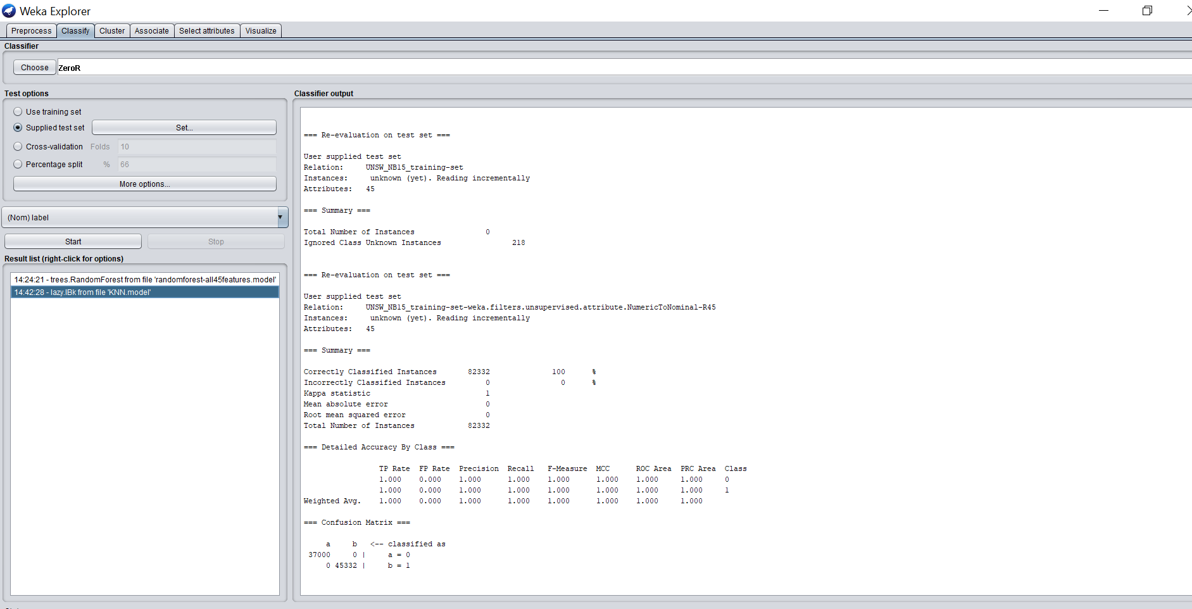

Random Forest Training Model :

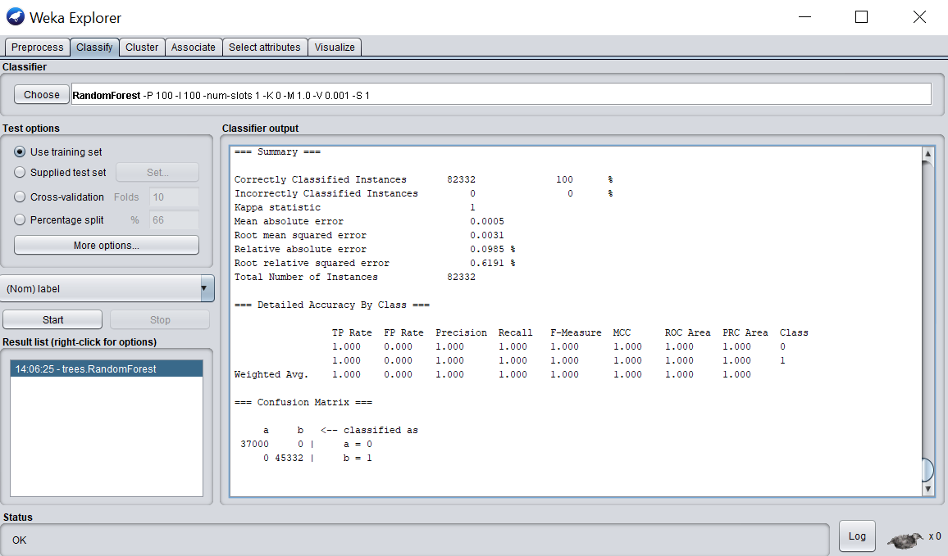

SVM Training Model:

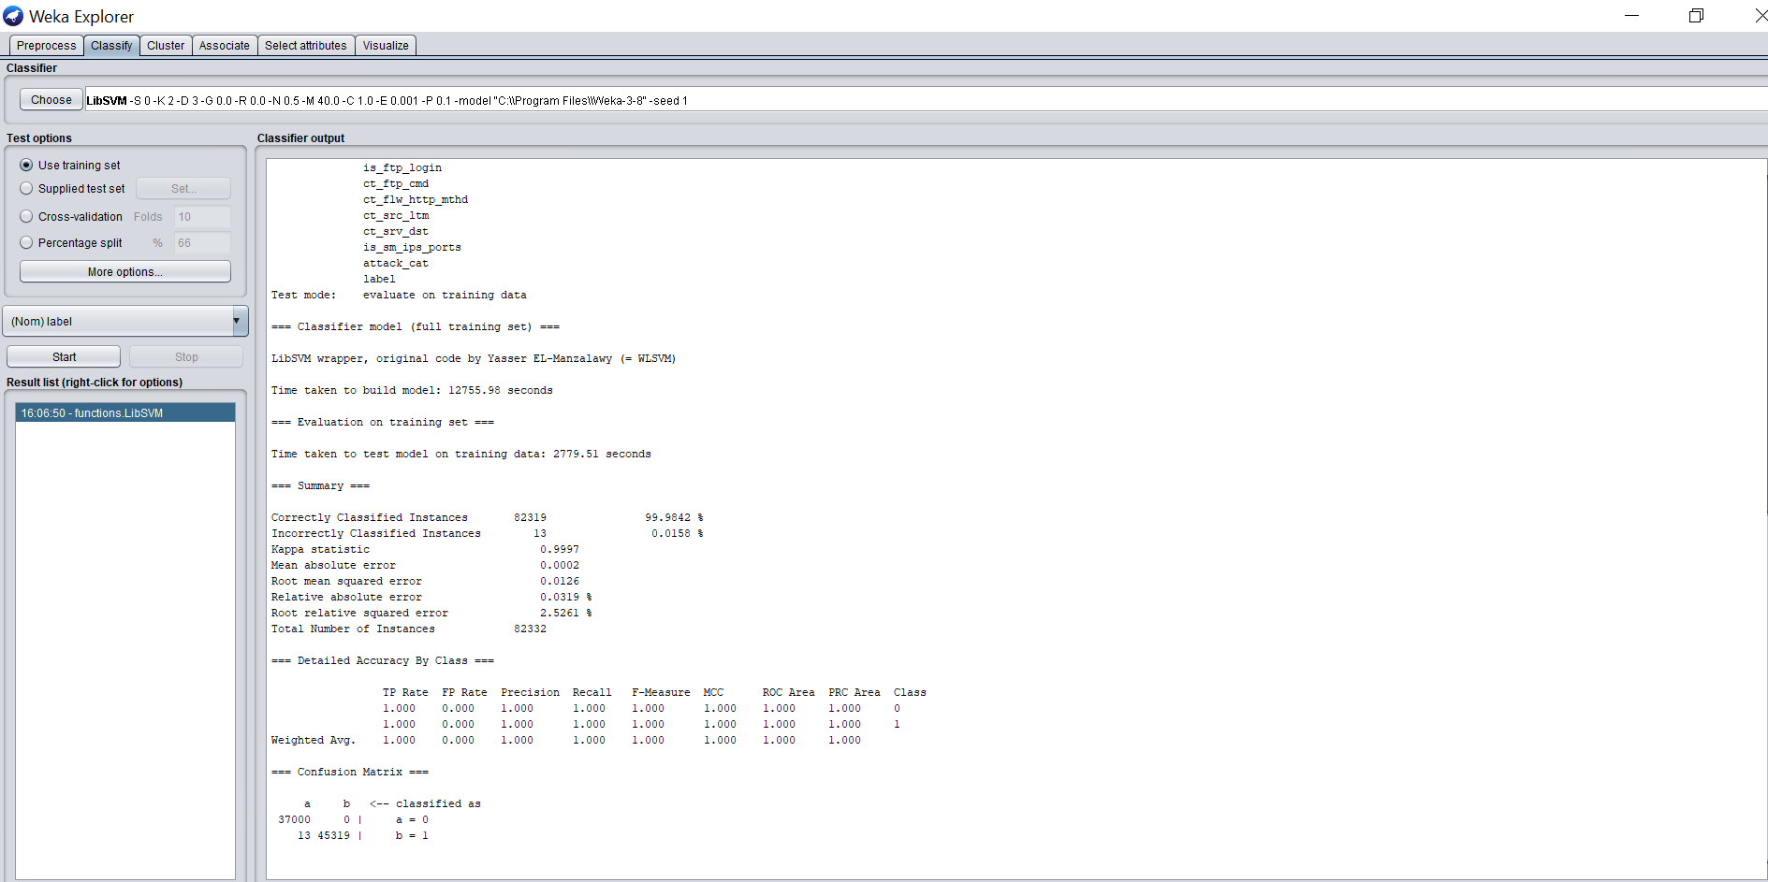

WEKA EXPERIMENTER MODULE ANALYSIS:

PERCENT CORRECT:

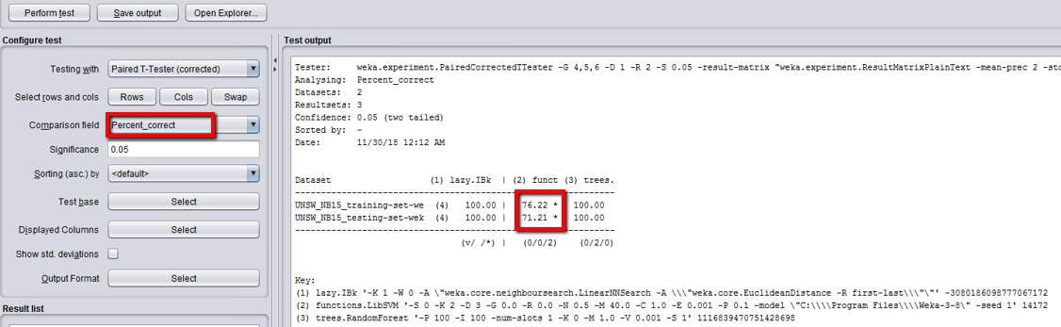

Root Mean Squared Error:

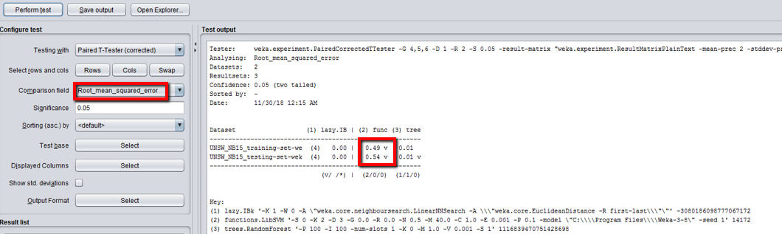

F Measure:

